CNS Experiment 006 Lab Report
From high-noise Cayley stress testing to local body-coordination monitoring

Investor-friendly and non-technical summary

Executive conclusion
Experiment 006 did not show that a Cayley graph can detect robot faults by itself in noisy data. It narrowed the problem into a more credible chain: first establish a trustworthy local state, then align the two sides of the gait, then ask whether the rest of the body can predict a local joint. In 006(c), a local graph-prediction residual detected short synthetic left-side deviations earlier and more reliably than the global graph score. This is a risk-signal result in simulation, not a claim that the robot can already prevent a fall.

One sentence for investors
The goal is not to teach a robot to walk. The goal is to give the system a chance, before loss of balance, to notice that its body parts are no longer cooperating as they do in normal walking.

1. Scope and boundary
CNS is a safety-check layer ahead of the robot’s existing controllers. It reads joint, IMU, and contact-related signals, and outputs normal, observation-unreliable, or structural-deviation risk. MPC, PID, and impedance control still create and execute motion. This experiment records the speed-reduction, recovery, or replanning advice they could receive; it does not change motor torques.
Tested here | Not claimed here
Can a repeatable normal body-coordination pattern be learned? | Directly improve balance or reduce falls
Can a short one-sided structural deviation be detected early? | Identify the failed motor, encoder, or friction value
Does a graph help with local deviations better than one global score? | Replace MPC, PID, or impedance control
Can weak observations be separated from structural deviation? | Prove real-robot or commercial performance

2. Why Experiment 006 matters
During normal walking, joints, torso motion, and foot contact are not independent. They cooperate in a repeatable pattern. Experiment 006 looks for a representation that does not mistake ordinary sensor noise for body mismatch, and does not average a small local problem away.
The resulting division of labour is simple: time-domain processing helps the system see clearly; the graph asks whether the body is still coordinated; the controller performs the action.

3. 006(a): high-noise Cayley stress test
006(a) began with the direct idea of organizing left-right joint relations as a Cayley symmetry structure and monitoring its residual under high mixed noise. The result was not robust enough. Background noise, local delay, impact spikes, and phase errors change spectral features. When all joints are compressed into one global score, a left-knee or left-ankle deviation can also be averaged away.
Finding in 006(a) | Effect on the roadmap
A Cayley graph is not a general-purpose denoiser. | Do not make Cayley the front-end filter.
Global symmetry residuals dilute local deviations. | Move from one global score to local node prediction.
A fixed half-period alignment creates false mismatch when gait rate changes. | Estimate task phase and left-right correspondence first.
Thresholds drift with noise level. | Calibrate false-positive rate on independent normal records.

This negative result is valuable. It prevents us from treating advanced mathematics as a universal alarm. Cayley and representation ideas remain possible tools for explaining symmetry, but they should not be asked to clean high-noise raw signals alone.

4. 006(b): normal relation graph and graph bandlimitedness
006(b) asked the more basic question: can normal gait be described by stable relations among a few functional blocks? A probability relation matrix was built from the left leg, a half-period-aligned right leg, torso IMU, and foot contact. Its training-to-independent-test difference was only 0.09%, while the bootstrap 95% difference was about 0.10%. Within this synthetic normal-gait setting, the relation template is repeatable.
The check also showed an important difference in signal role. Foot contact is impulsive, event-like data, whereas joint and torso motion are continuous. Forcing both into one low-frequency continuous graph produces a larger high-frequency tail. The conclusion is not that feet and hands are inherently different in every mathematical sense; it is that continuous motion states and contact events should have different processing roles.
006(b) data | Plain-language meaning
A training-test relative difference: 0.09% | The normal relation template repeated in the synthetic test.
Four-node graph, B=2: median high-frequency energy 0.95% | Most normal states are effectively low-dimensional.
Four-node graph, B=3: 95% high-frequency energy 12.30% | Contact events and rare moments still make a visible high-frequency tail.
Three-node continuous graph, B=2: 95% high-frequency energy about 4.3% | The two legs and torso fit a more stable low-dimensional continuous graph.

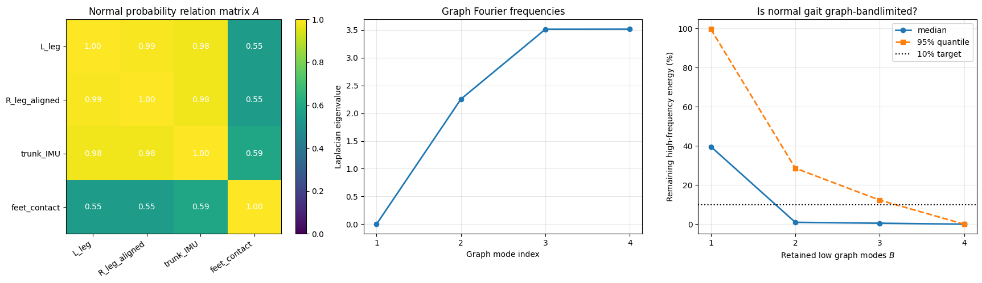
Figure 1. 006(b): normal relation matrix, graph frequencies, and bandlimitedness check.

5. 006(c): fixed physical graph and local structural prediction
006(c) no longer tried to prove that phase-gated graphs are better. Earlier, the high-frequency energies of phase-average and gated graphs differed by only 0.03 percentage points. Under ideal synthetic gait, gating added no information. The experiment therefore used a simpler, falsifiable fixed physical graph.
The nodes were left hip, knee, ankle; aligned right hip, knee, ankle; and torso IMU. Edges represented mechanical chains, left-right counterparts, and leg-to-torso relations. This avoids the earlier near-complete graph, where every node was so correlated that a local deviation was easily diluted.

5.1 Three processing layers
Layer | Non-technical explanation | Output
Casey-style local front end | Handles short noise, spikes, and minor delay, and says whether the present data are trustworthy. | Local reconstructed state and window confidence
EQUIMEA-style event alignment | Uses foot-contact events to estimate the gait period, so the two legs are compared at the same task phase. | Half-period aligned body state
Local graph prediction | Uses the right-side joints and torso to predict what a left-side joint should be doing. | Local structural residual

5.2 The key mathematical idea
For a left-side node i, first form its residual from the normal phase template, e_i. Then hide node i and use all other nodes in the fixed low-frequency graph space to predict it:
e_hat_i = predicted residual of node i from all other nodes
If the measured and predicted residuals disagree strongly, that joint is no longer explained by normal body coordination. Structural risk is gated by Casey confidence:
R_struct = Casey confidence × maximum local prediction error
Observation risk remains separate:
R_obs = 1 − Casey confidence
Low confidence is therefore not mislabeled as a structural fault. The system separates “we cannot see clearly” from “we can see clearly, but the body is uncoordinated.”

6. 006(c) results
Detector | Normal FPR | Short-event hit rate | Outside-event FPR | Median alarm delay
Time residual | 6.97% | 90.0% | 5.46% | 35.9 ms
Global graph high-frequency residual | 5.18% | 57.5% | 5.42% | 99.7 ms
Local graph prediction residual | 4.95% | 100.0% | 5.49% | 26.0 ms

All thresholds were calibrated independently on normal records for a target false-positive rate of about 5%. In the present synthetic short left-knee deviation test, local graph prediction performed best: it preserved local information, was not diluted by global averaging, and gave structural evidence when observations remained trustworthy.
The fixed seven-node physical graph also had a usable spectral gap: the separation between the retained low-frequency space and higher graph modes was about 1.04. This is more suitable for stable local prediction than the earlier three-node near-complete graph.
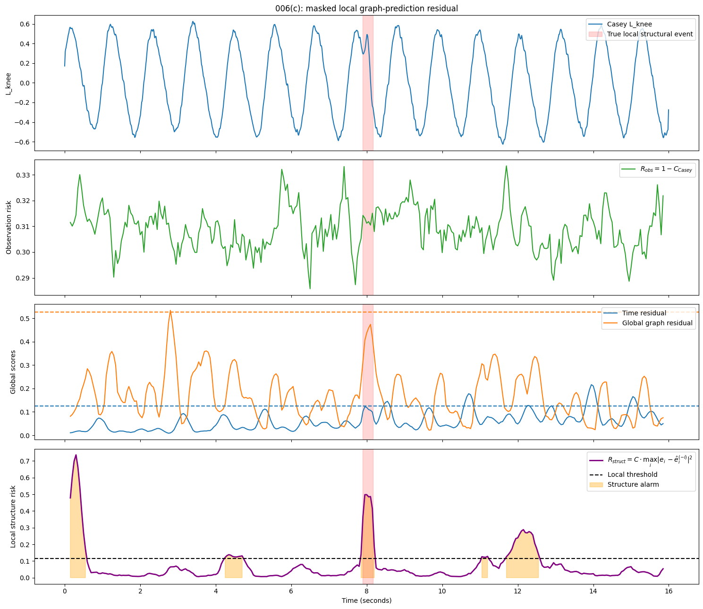
Figure 2. 006(c): local graph-prediction residual. The red band marks a true short structural deviation.

7. How to read the result
The 100% hit rate applies only to this round’s synthetic, short, one-sided left-knee deviations. The event was designed as a local joint deviation, and the local predictor was designed to test that kind of deviation. It is not a promise about wet floors, real slips, torque saturation, or hardware faults.
The durable method finding is that a global graph score dilutes local problems. Asking whether the rest of the body can explain one joint is closer to the actual task of a robot safety-check layer.

8. Effect on the product roadmap
Keep now | Do not add yet | Add only when
Casey-style trustworthy local state | Graphon | We need to generalize across robots, node counts, or many graph instances.
EQUIMEA-style event phase alignment | Dynamic phase-gated graph | The fixed graph demonstrably fails under real contact changes.
Fixed physical graph and local node prediction | Cayley as the primary detector | A verifiable left-right group action adds measured information.
Risk-signal interface to MPC shadow mode | Direct motor control | A later closed-loop dynamics experiment validates it.

The near-term product statement should remain conservative. CNS is not the robot’s brain, muscle, or replacement controller. It is a plug-in body-coordination check that offers observation confidence and structural-risk advice before the existing controller acts.

9. Next experiments
- Observation-fault ablation: inject only delay, drift, or dropout. This should raise observation risk, not casually trigger structural risk.
- Structural-deviation sweep: vary magnitude, duration, gait phase, and noise level, and report hit-rate curves with confidence intervals.
- Location generalization: inject short deviations in left hip, knee, ankle, right chain, and torso.
- Physical stress tests: add load change, speed change, lower friction, and contact-stiffness change to discover when the fixed graph fails.
- Control loop: only after the risk signal is stable, connect it to MPC shadow mode; later measure slip distance, torso angle, recovery time, progress, jerk, and energy.

10. Final conclusion
Experiment 006 changed the research roadmap. It did not support the simple idea of using a Cayley graph directly on high-noise signals. Instead, it established a more realistic chain: assess observation confidence, align gait task phase, then predict a local joint from the rest of the body. The strongest present evidence is 006(c): in synthetic data, local graph prediction detected short structural deviations earlier at about a 5% normal false-positive rate. The next test is not more elaborate mathematics; it is whether this risk signal remains trustworthy under more realistic physical disturbances.

